PRESS RELEASE
Public Relations Bureau
Bldg. I Fl. 2, Jl. M.I. Ridwan Rais No. 5, Jakarta 10110 Phone: 021-3860371/Fax: 021-3508711
www.kemendag.go.id

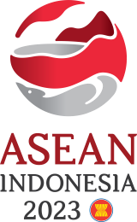
Chairing the 7th AEM-Hong Kong, PRC, Consultation

Trade Minister Zulkifli Hasan: Optimize ASEAN-Hong Kong Trade Potential
Semarang, 20 August 2023 – Minister of Trade Zulkifli Hasan said ASEAN and Hong Kong need to optimize the trade potential of the two economies. Hong Kong is the seventh largest trading partner for ASEAN and the fifth largest source of foreign investment in ASEAN. As for Hong Kong, ASEAN is the second largest trading partner and the sixth largest source of foreign investment. In addition, Hong Kong is also an important hub for international trade.

This was conveyed by the Minister of Trade Zulkifli Hasan while chairing the 7th Consultation Meeting of ASEAN Economic Ministers with Hong Kong, China (the 7th Consultation AEM-HKC) which was held on Sunday (20/8) in Semarang, Central Java. This meeting is part of a series of meetings of the 55th ASEAN Economic Ministers’ Meeting and Related Meetings held on 17-22 August 2023. Meanwhile, the Hong Kong Delegation was led by the Secretary for Commerce and Economic Development of Hong Kong, Algernon Yau.

"This is the 9th series of meetings during AEM in Semarang. The meeting discussed trade and investment cooperation and maximizing Hong Kong's potential as an important hub in international trade," said Trade Minister Zulkifli Hasan.

As Chair of AEM, Zulkifli Hasan also announced the completion of the First Protocol to Amend the ASEAN-Hong Kong, China/AHKFTA Free Trade Agreement regarding Product Specific Rules/PSR. "The First Protocol to Amend the AHKFTA will soon be signed by ASEAN and Hong Kong," said Trade Minister Zulkifli Hasan. On this occasion, Indonesia said that it had complied with procedures in accordance with domestic regulations and was ready to sign.

ASEAN and Hong Kong, continued Trade Minister Zulkifli Hasan, also discussed the Economic and Technical Cooperation Program which is expected to be utilized to increase the capacity of business actors in ASEAN, including Indonesia, to be able to enter the export market. At the end of the meeting, AEM Chairman Zulkifli Hasan also noted Hong Kong's desire to join RCEP.

"This meeting is an important momentum in order to strengthen cooperation between ASEAN and Hong Kong while at the same time strengthening the parties' support for Indonesia's Chairmanship of ASEAN this year," explained Trade Minister Zulkifli Hasan.

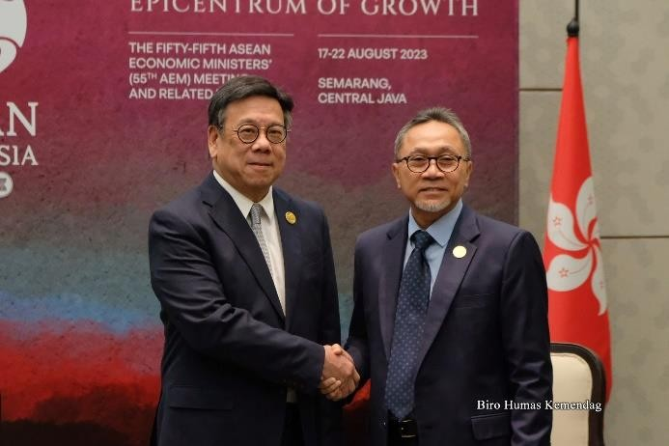 | 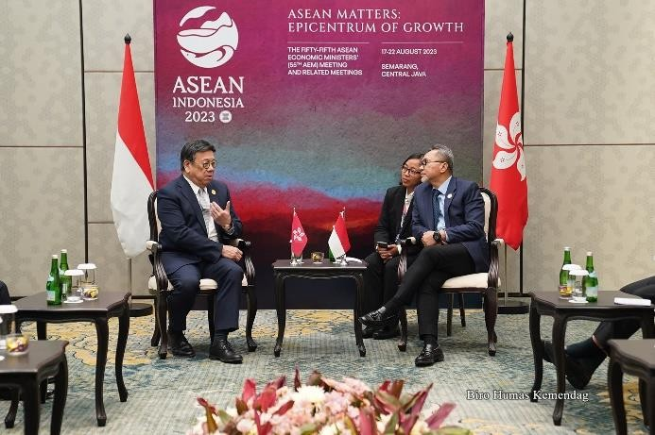

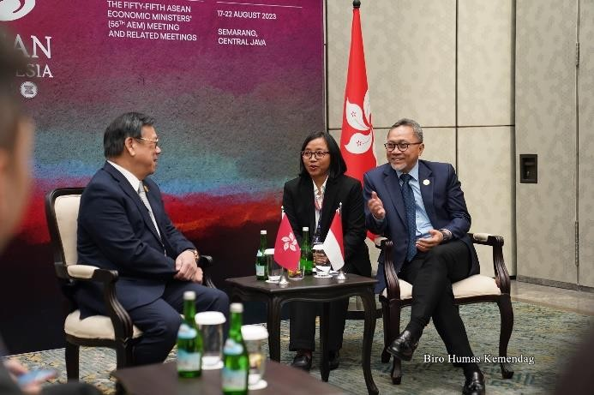 | 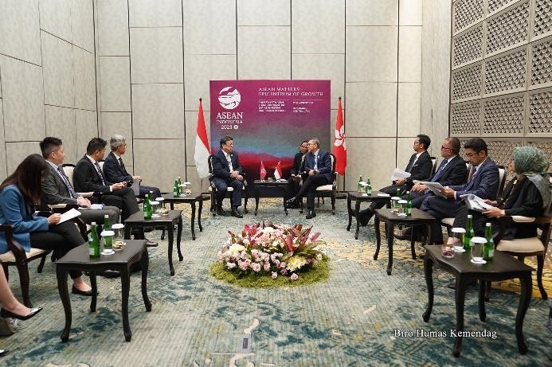

--end--

For further information please contact:  Ani Mulyati  Head of Public Relations Bureau Ministry of Trade  Email: pusathumas@kemendag.go.id | Dina Kurniasari  Director of ASEAN Negotiations  Directorate General of International Trade Negotiations Ministry of Trade  Email: asean@kemendag.go.id

